Unit of Study: Teaching the Six Traits in Informational Writing
Grades K-1: Voice: Taking Risk to Create Voice

Connection:
Many writers have difficulty expressing ideas in new ways. Adding voice to your writing makes the writing interesting and original. Today I will teach you that the writing should sound like the writer, not the writing, using his/her use of voice, “just right” words and phrases.

Teaching Point: – “I do”
Today we are going to read about a topic, a risky topic, that no one wants to talk about but one that every school has to deal with: head lice! Ewww …lice! I’ll read aloud Bugs in My Hair! written by David Shannon and we’ll learn new information about where lice comes from, how it feels to have lice and what to do if you get head lice. Then we will do something fun and will take on the view point of head lice and write about their lifecycle together. We’ll work together to find more information about head lice and put it all together.

Active Engagement: – “You do”
Now it’s your turn. You and a partner are going to choose a nonfiction book about one of the insects, animals or plants from our must read bookshelf and read it together. You will work together to write and illustrate a book to inform/teach about the lifecycle of the insect, animal or plant you are learning about. Write one step of the lifecycle on each page with an illustration that makes the page come to life, just like David Shannon did. Don’t just write facts; include both your voices into the writing to make it interesting and original.

Link to Other Writing:
Today and every day, when you are getting ready to write, especially to inform, think about taking risks to create voice in your writing. Informational writing does not have to be all about facts. Take risks to create voice when teaching your audience. I can’t wait to learn from all of you.

Mid-Workshop Teaching Point:
Remember writers, when you are writing to inform, take risks to create voice. Add your voice to make the writing more interesting and original.

Teaching Share:
I am excited to read all of your informative books. Your books will be on our must read shelf in our classroom so we could learn from all of you. Good job today writers thinking about voice when writing to inform.

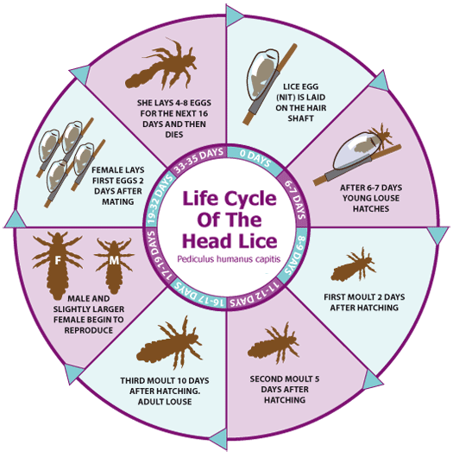

The life cycle of head lice has three stages: egg, nymph, and adult. Eggs: Nits are head lice eggs. They are hard to see and are often confused for dandruff or hair spray droplets. Nits are laid by the adult female and are cemented at the base of the hair shaft nearest the scalp.

Unit of Study: Teaching the Six Traits in Informational Writing
Grades 2-3: Voice: Establishing a Tone

Connection:
Writers care about their topic and it shows through their voice or tone. The writing is expressive and compelling. The reader feels the writer’s conviction, authority and integrity. Today I will teach you what tone is and how authors establish tone in their writing.

Teaching Point: – “I do”
Today we are going to read a hilarious book titled, The Beginner’s Guide to Running Away From Home written by Jennifer LaRue Huget. As we read, listen for the main character’s tone (petulant tone- irritated or angry) he uses as he explains why he’s running away and his plans for doing it. What do you notice? What do you hear?
Let’s make a list of words that describe the tone in this book compared with the tone of most how to books that we know.

Active Engagement: – “You do”
Now it’s your turn. You and a partner will work together to come up with the topic for another how to text with a distinctive tone like Huget’s and share ideas. Together you will write a brief how to using your ideas and establish the tone in your writing.
(Define tone as the author’s attitude toward his subject: serious, angry, playful, amused, authoritative, sarcastic, humorous, etc.)

Link to Other Writing:
Today and every day, when you are getting ready to write, especially to inform, think about and establish the tone in your writing.

Mid-Workshop Teaching Point:
Remember writers, when you are writing to inform, be sure to establish the tone in your writing to connect with the reader. Adding tone to your writing helps your audience “feel” your writing.

Teaching Share:
I am excited to read all of your How Tos. When you share your how to, we will think about and identify the tone in your writing. Good job today writers thinking about tone when writing to inform.

Unit of Study: Teaching the Six Traits in Informational Writing
Grades 4-5: Voice: Conveying The Purpose

Connection:
Writers make clear to their audience of their reason/purpose for creating the writing piece. Today I will teach you how the writer offers a point of view that’s appropriate for the genre (informational writing), which compels the reader to read on.

Teaching Point: – “I do”
Today we are going to read Clemente!, written by Willie Perdomo The purpose of this book is to introduce the reader to a person who life is worth remembering and emulating. The author accomplishes that by using voice to help readers relate to Clemente’s life. As we read, the author’s voice conveys the passion and commitment that Clemente had for the game of baseball and for the needs of others, especially the victims of the 1772 earthquake in Nicaragua.

Active Engagement: – “You do”
Now it’s your turn. Think of a person in today’s world that might be remembered for their good works and discuss with a partner the voice they’d use in those biographies. Research the person and write a brief biography using voice. Be sure to convey the purpose, making it clear your reason for creating the writing piece.

Link to Other Writing:
Today and every day, when you are getting ready to write, especially to inform, think about conveying the purpose by using voice to help readers relate to the writing.

Mid-Workshop Teaching Point:
Remember writers, when you are writing to inform, be sure to make clear the reason for creating the writing piece. Be sure to include a point of view that’s appropriate for the informational writing, which compels the reader to read on.

Teaching Share:
I am excited to read all of your biographies about people’s lives who are worth remembering and emulating. As you share your biographies, we will listen for the purpose and voice. Good job today writers thinking about conveying purpose and using voice when writing to inform.

